**Code Walkthrough**

This Flask application integrates multiple components for dynamic content creation, including news retrieval, summarization, article generation, and social media post creation. It uses YAML configurations, error handling, and structured agents/tasks via the **crewai framework.**

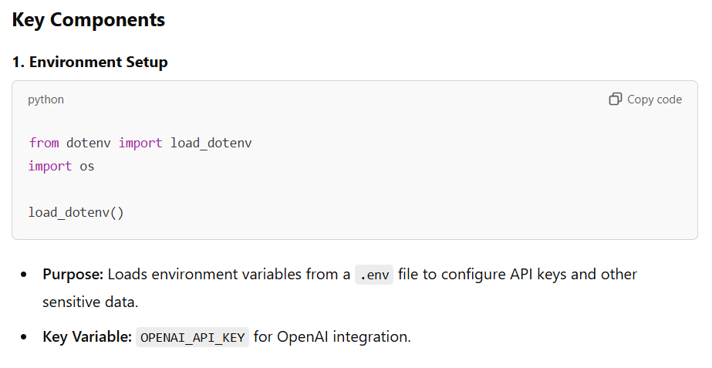

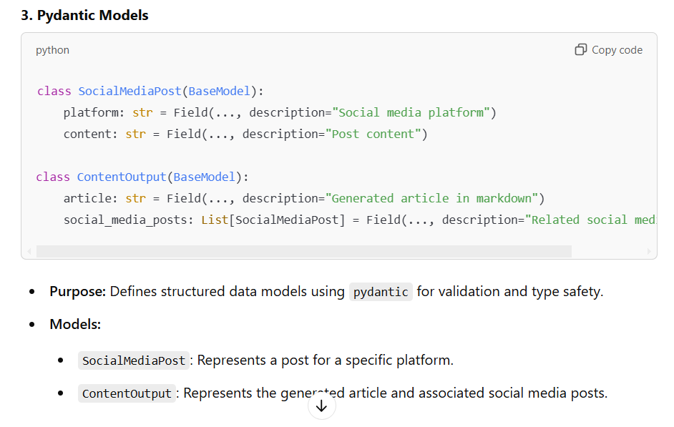

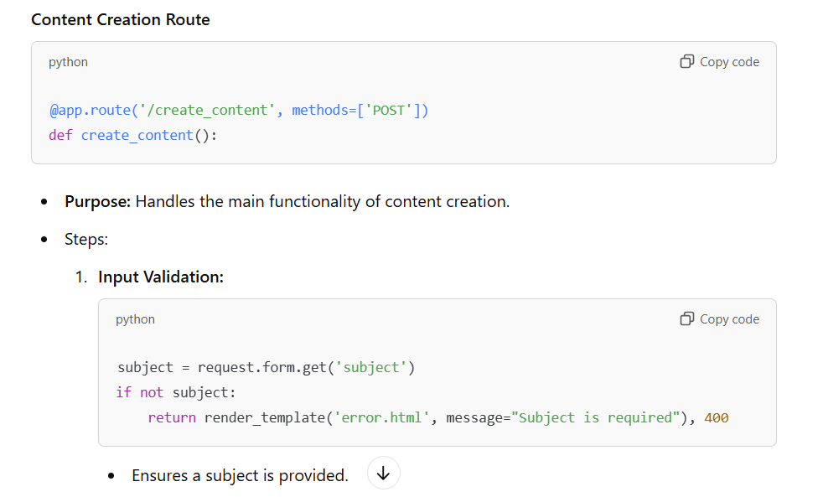

**PROJECT STRUCTURE:**

**AGENTS (YAML)**

**TASKS (YAML)**

